Air Quality Display

# HMI / DA Proposal

For the IoT project we were planning on logging some CO2 values all around TQ5. Having the data can be useful but if you cannot visualize it, it might not be easy to understand to the public. Considering the strawberry field, we have thought to propose a visual representation of the CO2 using a heat map.

For these data visualizations we could explore multiple options ranging from JavaScript or Python frameworks. We will explore both options and **if time is not an issue**, we will develop the project a little further and implement augmented reality. What we want to do with augmented reality is to define the levels of carbon dioxide by a color: Green, Yellow, Red (Low, Medium, High).

# Chart Wire frames

Heatmap

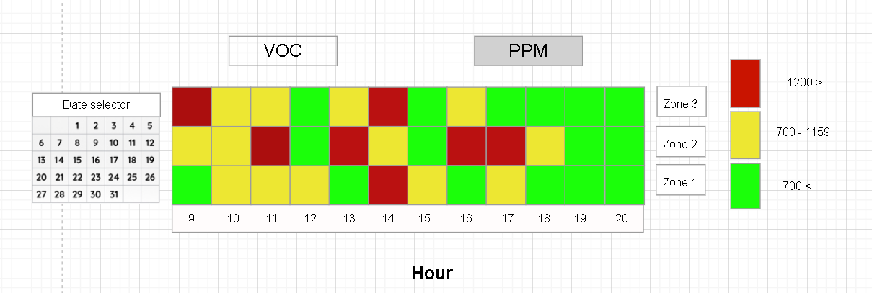One of the charts we want to use to display the data is going to be a heat map. This heat map will be used to represent the levels of the value selected on the top, VOC(Volatile Organic Compounds) or PPM(CO2). The right side will serve as a legend to indicate whether the levels are safe or not. The redder it gets, the higher the levels being read. This chart will help us compare the levels from different zones and compare them. This type of data is useful because it could give us insight on the amount of people gathered per area or a gas leak.

The values being displayed on this chart will be the average per hour.

## Chart, line chart Description automatically generatedTimeseries

PPM

VOC

This chart will be used to compare the values real time. We can have a more in depth look of what is happening around the building. The difference between this chart and the previous, is that the previous one is used for statistics vs this one is used to visualize the data. The timeseries chart will be less accurate as it could spike the levels if someone passes by or someone tampers with the sensor.